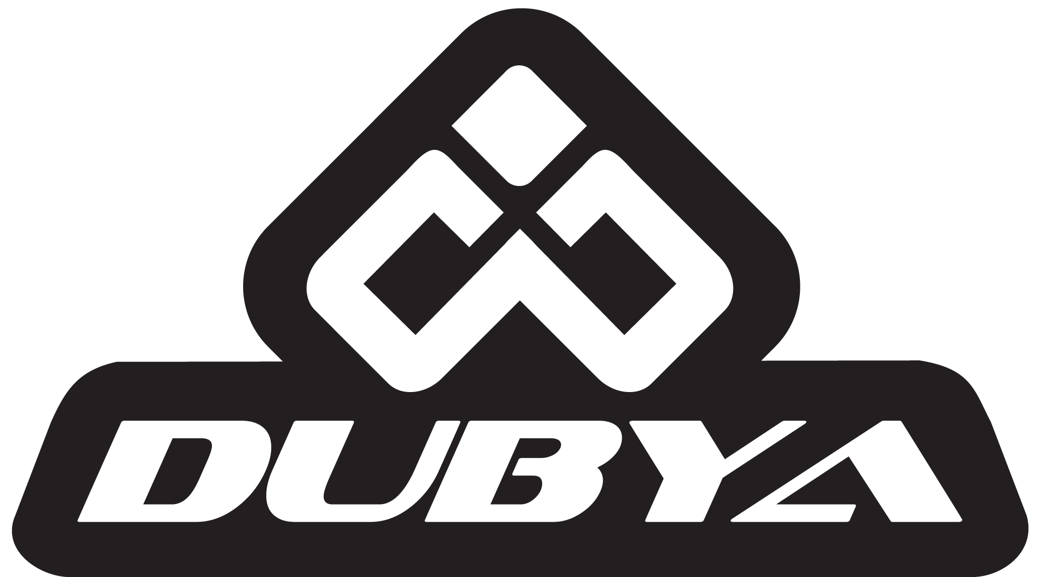
Dubya Sponsored Rider Davi Millsaps Claims
Supercross Season Opener
Orange, Calif. – January 7, 2013 – Rockstar Energy Suzuki’s Davi Millsaps claimed a stunning victory at Saturday night’s season opener for the 2013 Monster Energy Supercross Championship. This is Millsaps’ first Supercross win since his victory in San Diego during the 2010 season, and the first win for the Rockstar Energy Suzuki team in the Supercross class.
Millsaps demonstrated some serious speed all day, turning in practice times aboard his Suzuki RMZ450, equipped with hand-laced Talon/Excel wheels from Dubya USA, that would place him just behind championship favorites like Yoshimura Suzuki’s James Stewart and Monster Energy Kawasaki’s Ryan Villopoto. He then went on to take the win in his heat race, further demonstrating that he will be one to watch in this year’s deeply talented field.
During the main event, Millsaps showed no signs of slowing. He rocketed out of the gate to claim the holeshot, and lead most of the race. A heated battle with Team Honda Muscle Milk’s Trey Canard that lasted until the final lap kept fans on the edges of their seats, but at the checkered flag it was Millsaps that came away with the win.
Dubya USA constructs all of its race-ready wheelsets using only genuine components from top brands like Talon, Kite, D.I.D and Excel. Each wheel is hand constructed by one of Dubya’s experienced wheel builders in its Orange, California headquarters.
You can find more information about Dubya and its products by visiting their website at www.dubyausa.com. To keep up with the latest news and updates about Dubya’s sponsored riders as the 2013 Supercross season unfolds, be sure to like them on facebook at www.facebook.com/dubyausa, or follow @dubyausa on twitter or instagram.

