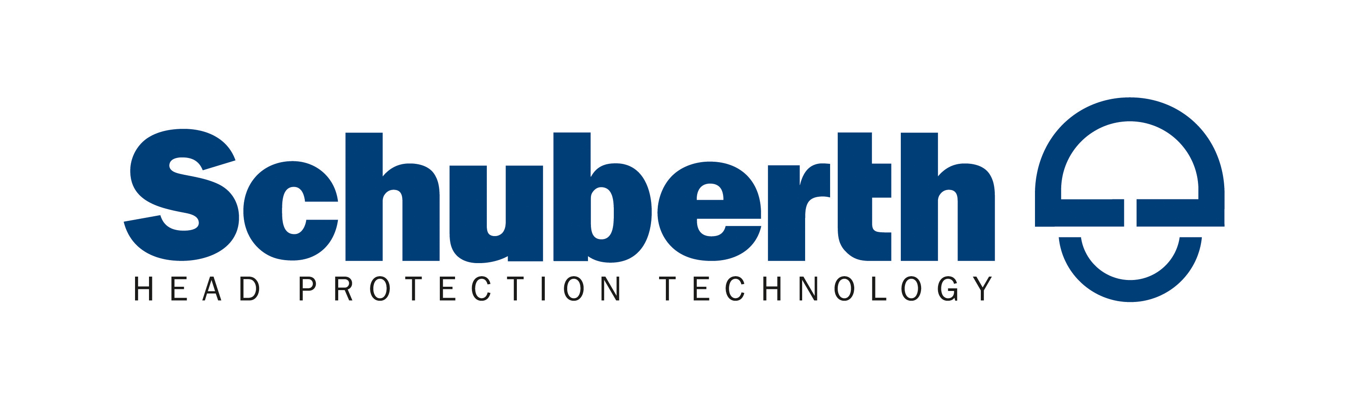

Schuberth Expands S2 Line with Sport Tech Graphic

- Schuberth has expanded its line of S2 full-face helmets with the new Sport Tech graphic.
- The first colorway in the S2 Sport Tech line is White/Red, and is now available through Schuberth dealers.

Aliso Viejo, Calif. – June 26, 2014 – Schuberth has expanded the S2 full-face helmet line with the introduction of the racy red/white/black Sport Tech graphic. The S2 Sport Tech in White/Red is now available at participating Schuberth dealers.

The S2 Sport Tech helmet is an ideal choice for riders who want to color-match their riding gear or their motorcycle. This latest graphic joins Lines and Ghost graphics options for the S2, in addition to solid colors.

For over 60 years Schuberth has created and built upon a tradition of head protection innovation, and the light, quiet S2 full face helmet continues that tradition as the world’s first motorcycle helmet to incorporate an internal antenna to enhance reception when using the optional Bluetooth® Schuberth Rider Communication System™ (SRC-System™).

“As a Superbike coach it's important to me that I see everything happening around me. The Schuberth visor so clear, nothing is distorted and there are no ‘bad spots’ at the edges of my peripheral vision. The ventilation is great even in the California high desert, and the micro-lock clasp is quick and easy even with gloves on, which is important to a guy who rides 15 sessions a day on the track. Overall the Schuberth S2 is a big win!” - Chris McVay, California Superbike School Coach

The S2 is a lightweight, ultra-quiet helmet that offers incredible protection thanks to Schuberth’s proprietary S.T.R.O.N.G. fiber construction. This DOT and European ECE compliant helmet features an integrated sun visor, a full-circumference rim spoiler, and a molded back spoiler. The optimized aerodynamics ensure reduced drag and wind noise, even at higher speeds.

Schuberth S2 Features include:
- Developed in Schuberth’s proprietary wind tunnel for optimized aerodynamics and aeroacoustics
- Equipped with Schuberth’s innovative Air Extraction System for customizable ventilation
- SRC-System™ ready with internal antenna for enhanced Bluetooth(R) and radio connectivity
- Schuberth’s S.T.R.O.N.G. fiber construction meets and exceeds DOT and ECE standards
- MSRP: $699 ($840 CAD)

The S2 full face helmet can be test ridden at California Superbike Schools nationwide and at select Schuberth dealers. For more information on the Schuberth helmet lineup, visit www.SchuberthNorthAmerica.com. Join the Schuberth community online on Facebook, and follow @SchuberthNA on Twitter. You can also connect on Instagram and YouTube.

About Schuberth GmbH: The German helmet manufacturer Schuberth has been developing and producing high-end head protection systems for over 90 years. With a multitude of innovative products, the company ranks among the world's leading manufacturers of motorcycle, Formula 1 and motor sport helmets as well as head protection for innovative solutions in industrial safety, fire fighting, the police and the military. The experience gained in particular from Formula 1, the pinnacle of motor sports, constantly provides fresh impetus for product developments that set the benchmark for head protection systems.
About Schuberth North America: In 2010, Schuberth GmbH opened the North American sister office in Aliso Viejo, California and continues to grow its exclusive dealer network for motorcycle products in the U.S. and Canada. Additional business segments work directly with law enforcement departments on the motor officer and crowd control products and with IndyCar and NASCAR teams on the auto racing helmets. In 2014, Schuberth North America also assumed U.S. distribution for German apparel and glove manufacturer Held.

